Summary of Different Types of Carbon−Carbon Covalent Bonds
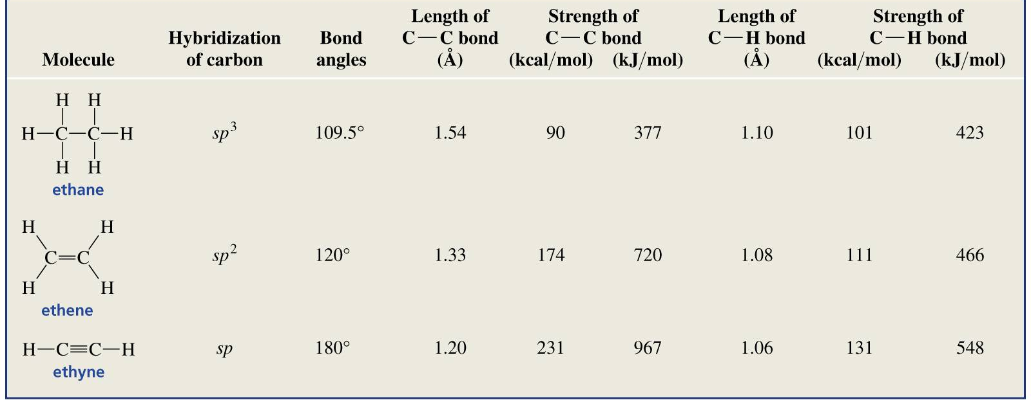
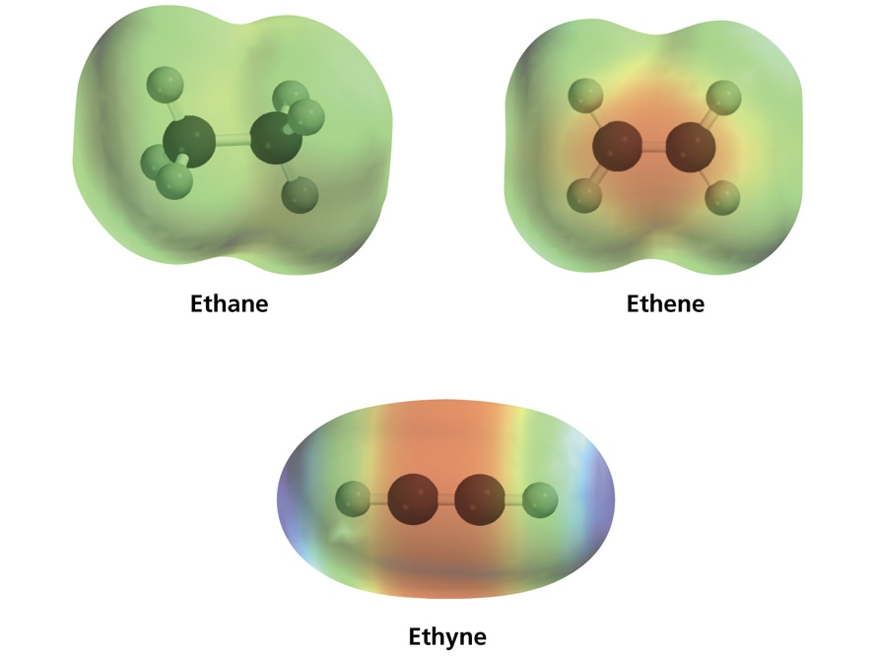
Other Key Points:
- The shorter the bond, the stronger the bond
- The greater the electron density in the region of orbital overlap, the stronger the bond
- The more s character in the orbital used for overlap, the shorter and the stronger the bond
- The more s character in the orbital used for overlap, the larger the bond angle
- The more s character in the orbital, the greater the electronegativity of that atom

