Futurity
Research news from top universities.

- 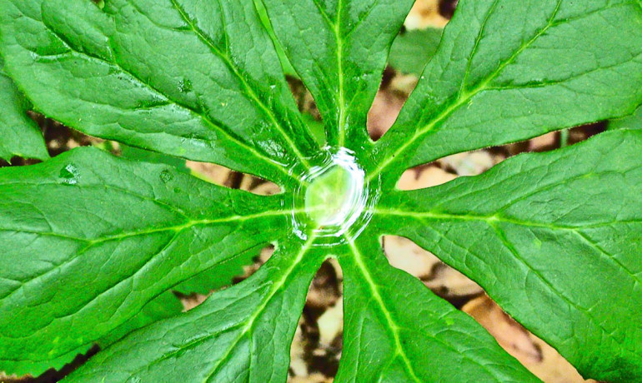
- "People have been grinding up plants to find new chemicals and testing their activity for a really long time," says Elizabeth Sattely. "What was striking to us is that with a lot of the plant natural products currently used as drugs, we have to grow the plant, then isolate the compound, and that's what goes into humans." (Credit: John McCullough/Flickr)

YEAST VS. PLANTS: HOW TO MAKE BETTER CANCER DRUGS
STANFORD UNIVERSITY
rightOriginal Study
Posted by Amy Adams-Stanford on September 14, 2015
You are free to share this article under the Attribution 4.0 International license.

Much of the medicine we take today to treat pain, fight cancer, or thwart disease comes from plants. But, some of those plants are endangered and may be the primary source of the drug.
Now, scientists have taken the machinery for making a widely used cancer drug from an endangered plant and put it in tobacco, a common plant that is easily grown in the lab. The tobacco plant then produced the chemical.
The scientists think they could apply the same technique to other plants and drugs, creating a less expensive and more stable source for medications.
“People have been grinding up plants to find new chemicals and testing their activity for a really long time,” says Elizabeth Sattely, assistant professor of chemical engineering at Stanford University. “What was striking to us is that with a lot of the plant natural products currently used as drugs, we have to grow the plant, then isolate the compound, and that’s what goes into humans.”
In her work, published in the journal Science, Sattely and colleagues used a new technique to identify proteins that work together in a molecular assembly line to produce the cancer drug. They then showed that the proteins could produce the compound outside in another more common plant. They hope to eventually produce the drug in yeast. Either the plant or yeast would provide a controlled laboratory environment for producing the drug.

The work could lead to new ways of modifying the natural pathways to produce derivative drugs that are safer or more effective than the natural source, Sattely says.
“A big promise of synthetic biology is to be able to engineer pathways that occur in nature, but if we don’t know what the proteins are, then we can’t even start on that endeavor.”

LEAF DEFENSE
The drug Sattely chose to focus on is produced by a leafy Himalayan plant called the mayapple. Within the plant, a series of proteins work in a step-by-step fashion to churn out a chemical defense against predators. That chemical defense, after a few modifications in the lab, becomes a widely used cancer drug called etoposide.
The starting material for this chemical defense is a harmless molecule commonly present in the leaf. When the plant senses an attack, it begins producing proteins that make up the assembly line. One by one, those proteins add a little chemical something here, subtract something there, and after a final molecular nip and tuck, the harmless starting material is transformed into a chemical defense.
The challenge was figuring out which of the many proteins found in the mayapple leaf were the ones involved in this pathway. Sattely started with the realization that the proteins she needed to find weren’t always present in the leaf. “It’s only when the leaf is wounded that the molecule is made,” she says.
And if the molecule is only made after wounding, the proteins that make that molecule are probably also only around after a wound as well. The question then became, “What are all the molecules that are there after wounding?” Sattely says.

It turns out that after damaging the plant leaf, 31 new proteins appeared. The researchers put various combinations of those proteins together until they eventually found 10 that made up the full assembly line. They put genes that make those 10 proteins into a common laboratory plant, and that plant began producing the chemical they were seeking.
The eventual goal is not simply moving molecular machinery from plant to plant. Now that she’s proven the molecular machinery works outside the plant, Sattely wants to put the proteins in yeast, which can be grown in large vats in the lab to better provide a stable source of drugs.

Producing a drug in yeast also provides some flexibility that isn’t present when isolating a drug from plants. “We can only use what the plant gives us,” Sattely says.
In yeast, scientists can modify the genes to produce proteins with slightly different functions. For example, they could nip a little more off the chemical or add a slightly bigger side chain, or subtly alter the function of the eventual drug.
It may also be possible to feed the yeast a slightly different starting product, thereby changing the chemical that the molecular assembly line churns out. These approaches would provide a way of tweaking existing drugs in an effort to improve them.
The work is a good example of how chemistry can be applied to problems of human health, Sattely says. The technique to find the pathway in mayapple could be applied to a wide range of other plants and drugs.
“My interests are really identifying new molecules and pathways from plants that are important for human health.”

Source: Stanford University
DOI: 10.1126/science.aac7202
Related Topics: biomimicry, biotechnology, cancer, medications, plants
NEXT UP

© 2015 Futurity. All Rights Reserved.

